Welcome to LionPATH Faculty Center Grading. The Faculty Center Grade Roster will provide you with functionality that allows you to pull grades from either ANGEL or Canvas (LMS). It also provides you with the ability to enter a participation category and last date of attendance if a student attended part of the semester. The instructions below will guide you through the process of entering your grades, entering participation and last date of attendance, approving your grades, and finally, changing any grades from the prior year.
Setting the Stage
Here are a few helpful facts that will help you understand how grading works in LionPATH.

- Instructors are assigned to classes with a specific role, either “Grade” or “Approve”.
- The Grade role is assigned to secondary instructors, such as TA’s or administrative staff who may be tasked with entering in grades initially.
  - Users who are assigned with the grade role will be able to populate the grade roster with a valid grade, or pull grades from either LMS. This user will also be able to change the status of the grade roster to “Ready for Review”.
- The Approve role is assigned to Primary Instructors for the class.
  - Faculty who are assigned with the approve role may be responsible for entering grades, and must approve grades. The approval of the grade roster is required before grades are posted to a student’s academic record.
- The Campus and College schedulers are responsible for assigning instructors to classes with the appropriate role. If you have any questions about this please contact your scheduler.
- Instructors have the ability to change grades for multiple terms, and to grade the current term. If you have taught classes in prior terms, you may log into LionPATH and be active on a prior term. When you first log in, verify the term that you are viewing. To change your term, simply select the green button titled: change term.
Navigating LionPATH
Go to http://launch.lionpath.psu.edu/ and select Faculty/Staff from the menu bar. Then select the quick link titled “Log in to LionPATH”. Once you successfully log in to Web Access, you will be directed to the LionPATH home page, where you will see a Menu on the left. If you need assistance logging into Web Access please contact the Help Desk by calling 814-865-HELP(4357) or email ITServiceDesk@psu.edu.
From the Menu in LionPATH, select the following menu items:
- Self Service
- Faculty Center
- My Schedule
When you enter the My Schedule page a term (semester) value will be displayed. To change the term (semester) select the green button titled “change term”, then select the desired term, then press the continue button.

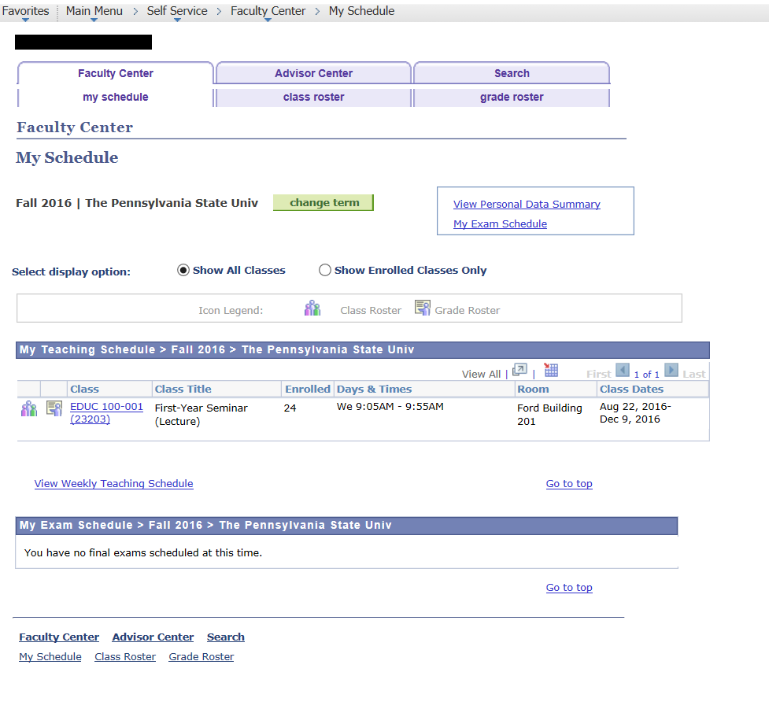
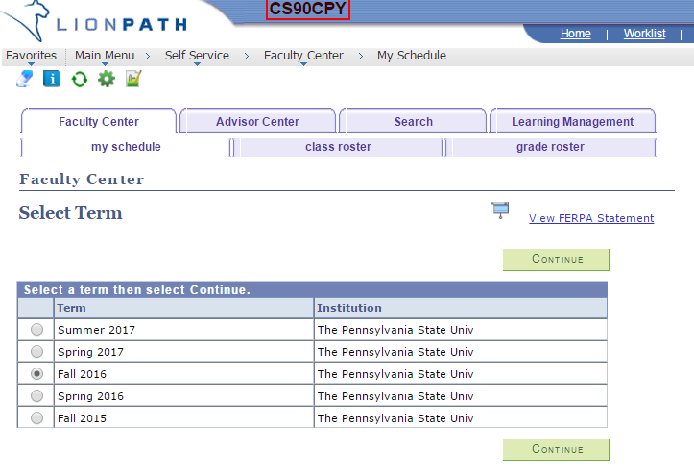

Selecting a Grade Roster
Once you have selected the desired term, you will see classes listed on your My Schedule page that you are assigned to as an instructor. The gateway to the grade roster is through the icon to the left of the Class in the “My Teaching Schedule” section. The icon for the grade roster is circled below. The icon for the grade roster will only appear once the Office of the University Registrar has created the grade roster. Grade rosters are generated at or near the conclusion of a class.

Details of the Grade Roster
Once you have entered the roster, you will see basic class information at the top of the page. Please verify that you are in the correct class. Remember, also check the term (semester) value to ensure you are in the correct class. If you are not on the correct class, you will have the option to select a different class from this page, simply select the change class green button and follow the directions.

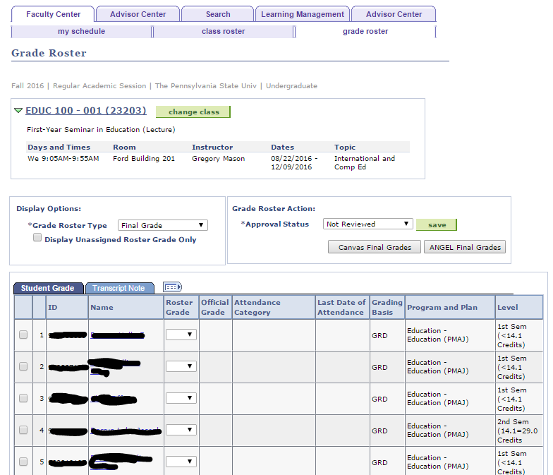

Attendance Category – this field will require input values if a grade of F, DF, or NG are assigned to a student. The purpose of this field is to indicate if a student attended a class the entire semester, part of the semester, or not at all. Population of this field is required for these three grades before a roster can be marked “Ready for Review” or “Approved”.
Last Date of Attendance – this field will allow input values only if a grade of F, DF, or NG are assigned, AND the participation category is “Participated Partial Semester”. Population of this field is required for these three grades before a roster can be marked “Ready for Review” or “Approved”.

Managing Roster Options
There are two boxes below the class information on the grade roster.
- The box on the left (Display Options) allows you to look at different roster types, in LionPATH there is only one roster type called Final Grade. You are also presented with a check box that allows you to display students in the roster that do not have a roster grade entered. This functionality is helpful in finding students on large rosters that still need grades assigned.
- The box on the right (Grade Roster Action) is where the status of the roster will be managed.
  - Grade Rosters have three Approval Status options, Not Reviewed, Ready for Review, and Approved.
    - Not Reviewed: Allows users with the Grade or Approve role to pull grades from either LMS, or manually enter grades for students. This status should not be changed until you have entered the grades, participation category, or last date of attendance, and you are ready to either approve, or have the primary instructor approve the grade entries.

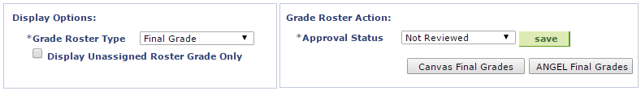

    - Ready for Review: This status lets an instructor with the Approve role know that they may now approve the grades. Only primary instructors with the Approve role may change this status to Approve. Only the primary instructor may change this status from Ready for Review to Not Reviewed. When the status is Ready for Review, you cannot change grades, but must change the status back to Not Reviewed in order to make additional changes.
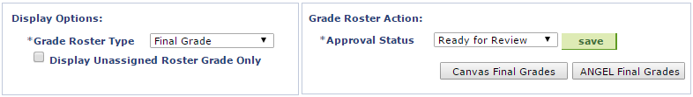

- Approved: This status is the final status before a grade roster is officially posted to a student’s academic record. All students on a grade roster must have a grade assigned before the roster may be approved. All grades of F, DF, or NG must have a participation category, and last date of attendance selected if the student participated for part of the term. The Office of the University Registrar will be running a process to collect the grades in Approved status and posting as the official grade which will make them available to students. Once you have approved the grades, you are essentially finished with your grades for that class.
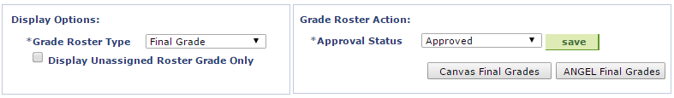
    - Save: The save button, to the right of the approval status menu, should be selected when you make a change to the approval status. Each time you change the approval status, you should select the save button.

Pulling Grades from ANGEL or Canvas
LionPATH has been set up to allow instructors with Grade and Approve roles assign grades to the LionPATH grade roster directly from the LMS roster of choice. If an instructor has completed the grade book in one or both of the LMS’s they may select either option by selecting the Final Grades button associated with that LMS. Instructors may change which LMS grades are pulled simply by selecting the alternative choice.
Important Points
- If you pull grades from one LMS and wish to choose the other LMS the instructor will receive a Message that Importing grades from the other LMS, will overwrite any unposted entries.
- If there are grades missing from either LMS, the students with missing grades will need to be graded in order for the instructor to change the Approval Status to Approved.
- All students on a grade roster must have a grade assigned before the roster may be approved.
- Students who have not officially enrolled in a class through LionPATH, will not be present on the grade roster, and any grades associated with that student in either LMS will not be recorded in LionPATH and will not be on the student’s academic record.
- Any student who has officially withdrawn from the University, or has late dropped this class, will automatically be assigned a grade of W or LD respectively.
- Any student who is assigned an F grade, DF grade, or NG grade must also have a participation category selected.
- Any student who is assigned a participation category of Participated Partial Semester must also have a last date of attendance.
- Participation Categories and Last Date of Attendance must be entered into the fields provided before the status of a class may be adjusted.
- Grade rosters with F, DF, or NG grades may be saved, however, they will not be processed until appropriate fields are entered and the roster is approved.

Entering Grades for Students
The Grade Roster lists students alphabetically and is case sensitive. This means that in some cases, the sort order may be different than the LMS’s. If entering grades manually, please be careful to select the correct student. To grade a student manually, select the available grades from the Drop-Down menu in the Roster Grade column. If assigning an F, DF, or NG grade, the Attendance Category will provide a drop down menu, select the appropriate options of Participated Entire Semester, Participated Partial Semester, or Never Attended. If Participated Partial Semester is selected, enter the Last Date of Attendance. The example below show some students with grades already populated. When grades are imported from the LMS, any invalid grades will appear blank as they do below. Once you have entered a grade for each student, remember to change the Approval Status at the top of the roster. Until this status is marked “Approved” the student will not be able to see the grades entered.
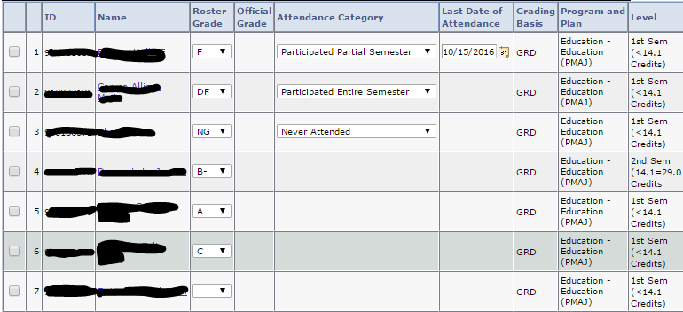

Additional Grade Roster Options
At the bottom of the Grade Roster, instructors are provided with some easy to use tools to help enter grades. If you are not using either LMS, or you just wish to enter grades manually, you may use these options to be more efficient.
- If a class has more than 20 students enrolled, the roster will display 20 rows at a time, unless the view all option is selected.
- If a single grade is given to all students, use the Select All link, and the “add this grade to selected students” feature. You may also just select a few students at a time for this feature.
- If you wish to notify students, you may use the appropriate option to notify students along with selecting the desired students.
- If you have entered grades for a class, and wish to leave the page and return later, be sure to select the “Save” button at the bottom or top of the roster.
